МИНИСТЕРСТВО НАУКИ И ВЫСШЕГО ОБРАЗОВАНИЯ  
РОССИЙСКОЙ ФЕДЕРАЦИИ

федеральное государственное автономное   
образовательное учреждение высшего образования  
«Самарский национальный исследовательский университет   
имени академика С.П. Королева»

(Самарский университет)

Институт информатики, математики и электроники

Факультет информатики  
Кафедра суперкомпьютеров и общей информатики

**Отчет по лабораторной работе №1**

Дисциплина: «Development and Operations (DevOps)

(Развертывание и жизненный цикл программного обеспечения)»

Тема: **«Virtual Box, Packer, Vargant, Git»**

Выполнил: Артамонов Н.С.

Группа: 6233-010402D

Самара 2018

**ASSIGNMENT**

In this Assignment you will learn how to work with Packer and Vagrant (ang VirtualBox, Git by the way).

Packer - is an open source tool for creating identical machine images for multiple platforms from a single source configuration. Vagrant - is a tool for building and managing virtual machine environments in a single workflow.

After installing the required tools, you will need to ensure that your computer can find the executables to run them. For this, you might need to modify the PATH environment variable. A good overview is at superuser.com. You may need to search the web for instructions on how to set the PATH variable for your specific operating system and version.

**Setting up your local machine**

* Install VirtualBox
* Install Vagrant
* Install Packer
* Clone the forked repo to your local machine using this command: git clone https://github.com/j-avdeev/DevOps/tree/master/Assignment1-VirtualBox-Packer-Vagrant-Git, or just download repo to your local machine.

**Part I: Building a box with Packer**

From the packer-templates directory on your local machine:

* Copy packer binary file to "packer-templates" folder
* Run packer build -only=virtualbox-iso application-server.json to create virtual machine box accrodingly to application-server scenario. You may see various timeouts and errors, as shown below. If you do, read Troubleshooting or retry the command until the ISO download succeeds:

read: operation timed out

==> virtualbox-iso: ISO download failed.

Build 'virtualbox-iso' errored: ISO download failed.

checksums didn't match expected

==> virtualbox-iso: ISO download failed.

Build 'virtualbox-iso' errored: ISO download failed.

==> Some builds didn't complete successfully and had errors:

--> virtualbox-iso: ISO download failed.

* Run cd virtualbox to go to packer-templates/firtualbox folder
* Run vagrant box add ubuntu-14.04.4-server-amd64-appserver_virtualbox.box --name devops-appserver
* Run vagrant up
* Run vagrant ssh to connect to the server

**Part II: Cloning, developing, and running the web application**

* On your virtual-ghost machine run git clone https://github.com/chef/devops-kungfu.git devops-kungfu
* Open http://localhost:8080 from your host-machine browse to see the app running.
* In the VM, run cd devops-kungfu
* To install app specific node packages, run sudo npm install. You may see several errors; they can be ignored for now.
* Now you can run tests with the command grunt -v. The tests will run, then quit with an error.

**Troubleshooting**

If you encounter errors with Ubuntu version numbers not being available or checksum errors on Ubuntu,it means that this repository has not yet been updated for the latest Ubuntu version. Meanwhile, you can fix this error for yourself by editing the contents of the application-server.json and control-server.json template files inside the packer-templates folder.

* Find the newest version number and checksum from the Ubuntu website for this release
* Edit PACKER_BOX_NAME and iso_checksum in the template files to match that version number and checksum.

**TASK PROGRESS**

**Part I**

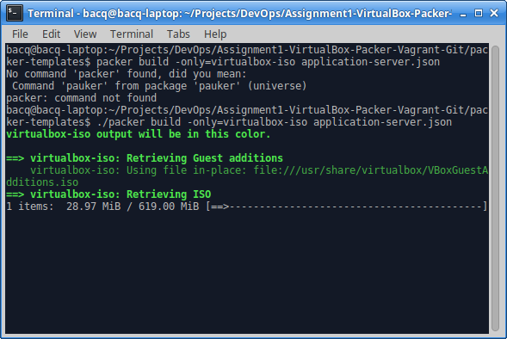

Figure 1 – Downloading virtual box image of operation system

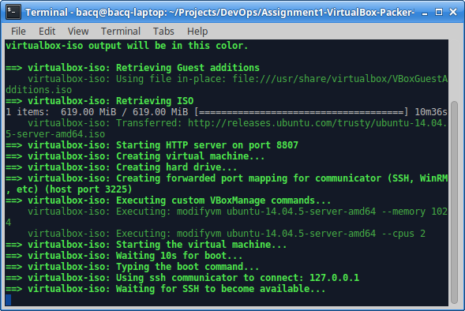

Figure 2 – Starting virtual machine

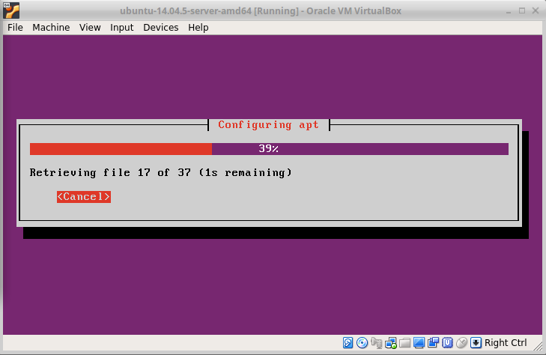

Figure 3 – Installing operation system

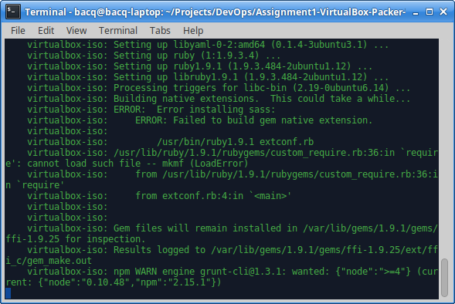

Figure 4 – Setup log

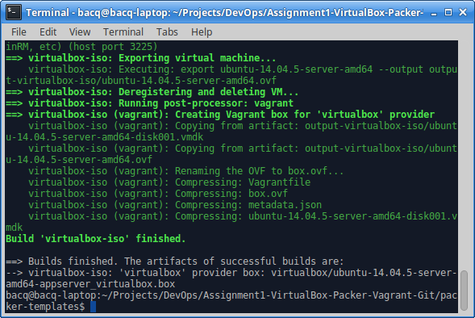

Figure 5 – Creating Vargant box and building Virtual Box image

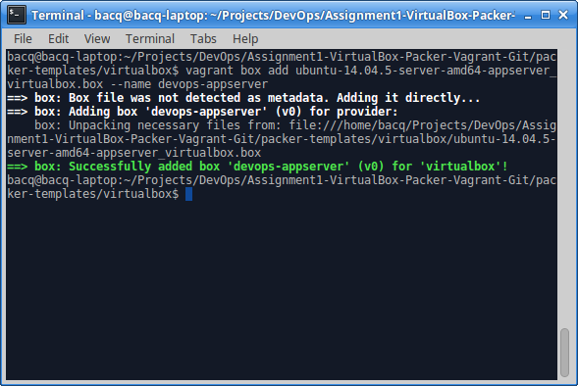

Figure 6 – Addition of the DevOps server for Virtual Box image

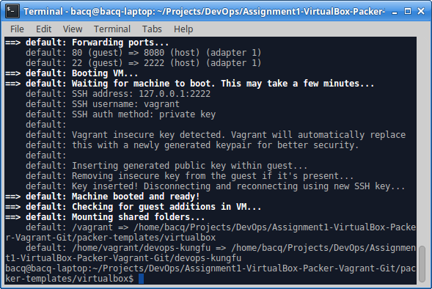

Figure 7 – Starting Virtual Box image

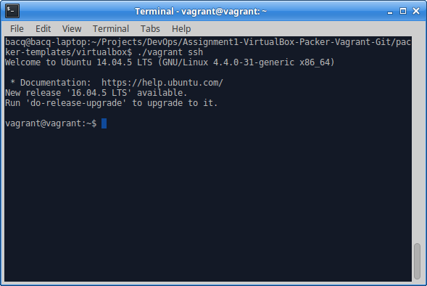

Figure 8 – Connecting to operation system throw ssh

**Part II**

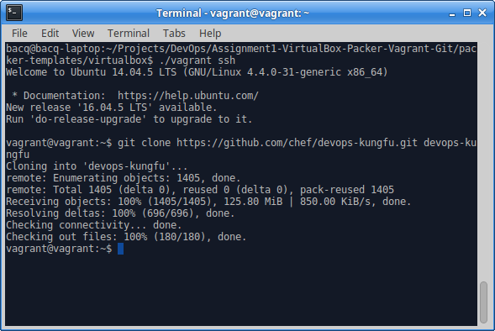

Figure 9 – Clonning devops-kungfu git repository

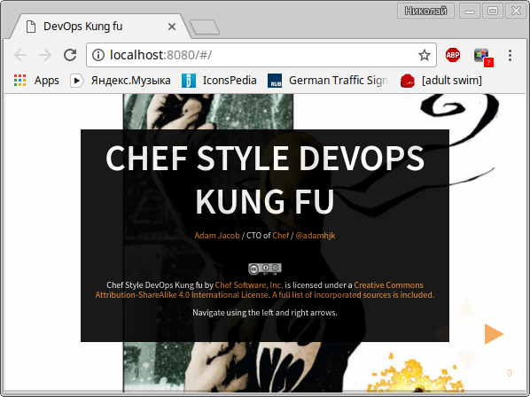

Figure 10 – Working devops-kungfu server

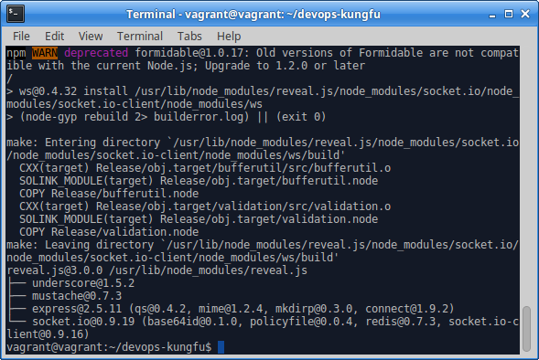

Figure 11 – Installing app specific packages

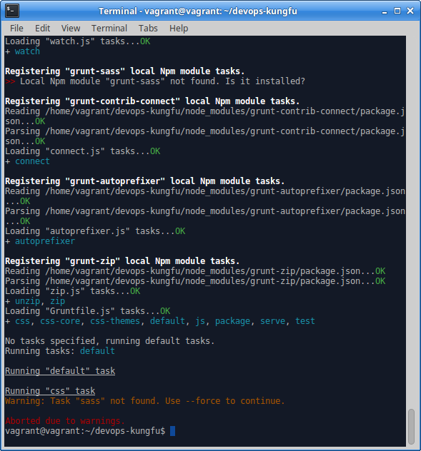

Figure 12 – Results of running tests